Talk for service 19th July 2020: Based on the Parable of the Tares
(Matthew 13: 24-30, 36-43) By Tessa Carrick

Introduction:
This year’s spring was so beautiful. It was a great help with coping with the Covid-19 lockdown as we watched buds bursting, leaves expanding and then the flowers appearing. Like so many people, all our family seemed to be growing beans and peas and sending Whatsap photos of their progress. But we didn’t have suitable space, living in a flat – in the end Mike persuaded me, who once had a classroom laboratory full of exotic and ordinary plants, to grow a few cress seeds on the windowsill. Growing plants seems something that everybody gets a buzz from, especially if the plants grow up healthy. Gardens have been a great help to many in this shutdown and many are immaculate. But I hope that everyone has left a few corners with a few weeds for wildlife. We are being urged to leave a space in the garden for wildlife.

This parable of the wheat and the tares is about a crop which is spoilt by weeds. One of the books I read used the term “images” as a substitute for parable, and it is certainly true that Matthew’s Gospel includes Jesus standing in a boat ate the edge of the lake, speaking to the crowd, giving one parable after another, presenting a series of images. Each parable or image portrays a slightly different aspect of what it means to follow Jesus and his view of good living.

The parable of the tares is only in the gospel of St Matthew. And, it is unusual in that Jesus is asked to explain it. In fact, I did not find it easier to interpret because Jesus had explained it.

In this parable, someone evil, the devil perhaps, spreads bad seed among the seed planted by the farmer.

I couldn’t resist this ancient German depiction of the devil sowing tares
(see next page).
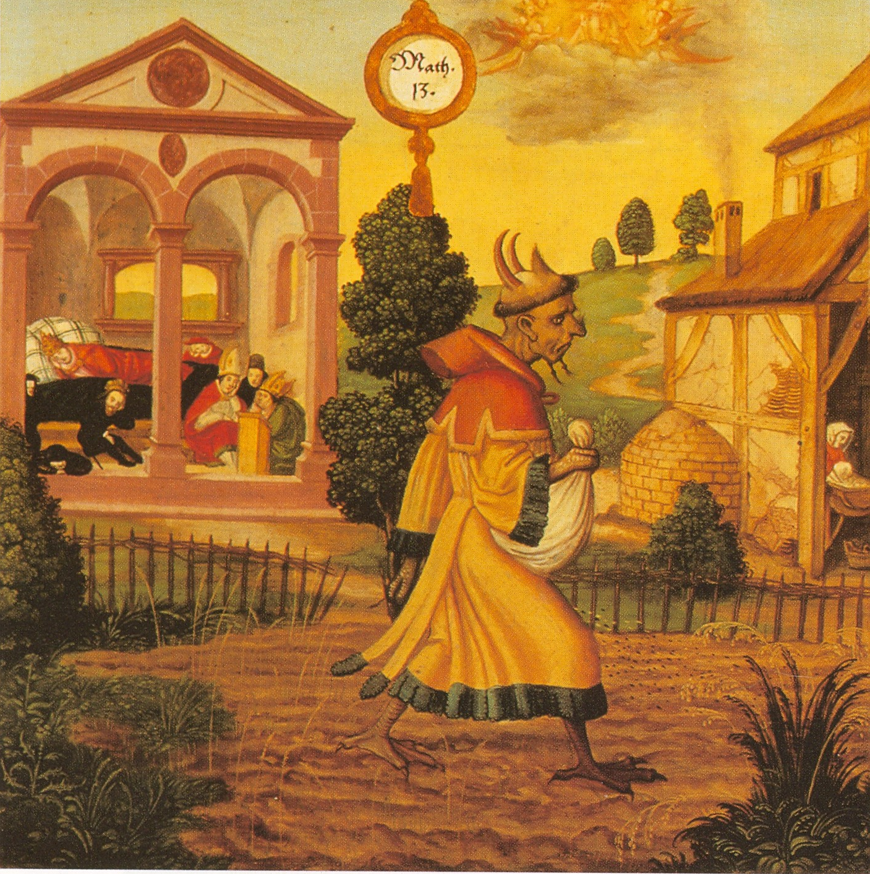

The weeds which contaminate the wheat crop are called “tares”. If you look up “tares” in a good flower book you will find the name used for a very tiny member of the pea family. It produces exquisite miniature pea pods which would fit well in a dolls’ house kitchen. But the Bible uses “tares” for a kind of grass which looked rather like the wheat, probably emmer wheat, a very ancient variety. Tares are sometimes known as darnel rye grass.

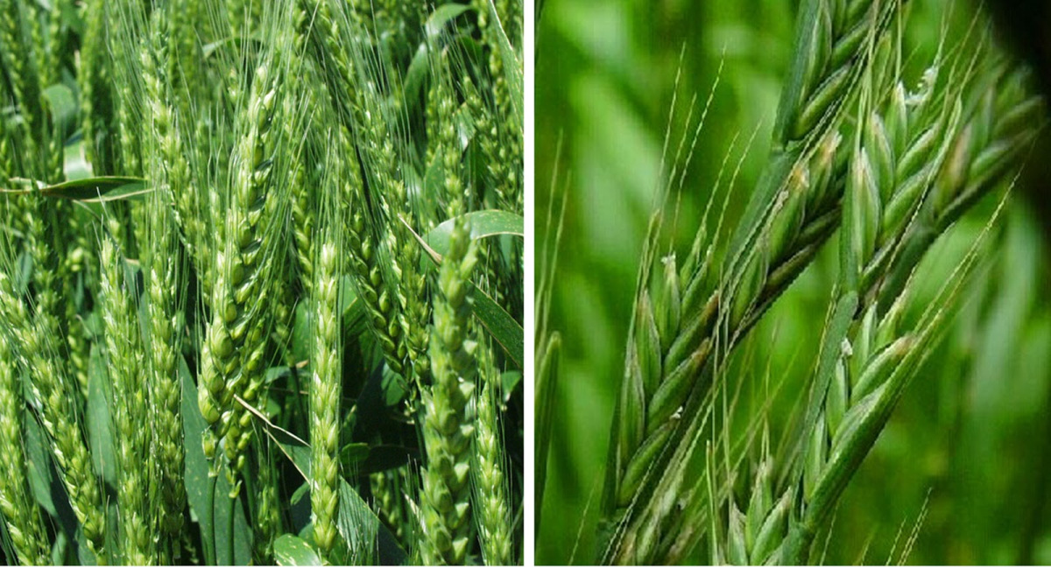

WHEAT: before it is fully ripe. TARES (Darnel): Lolium temulentum

It’s quite difficult for us to imagine a mixture of crop and weed because today modern agricultural methods with herbicide and pesticide treatment mean that crops are rarely contaminated. Suzanne Thompson mentioned to me this last week a field that she had seen near the M42. She said “There isn’t a weed to be seen among the wheat but he (the farmer) has certainly given free rein to nature along the edge. If only the meadow (part of our All Saints’) churchyard had the (same) amazing variety of wildflowers and butterflies (as his field headland has).”

What is the meaning of this parable? – the farmer allows the tares to grow up alongside the good plants. Is this referring to good and evil people? Or, is it talking about that in each of us there are good things, good aspirations, and there are things we would ourselves rather overlook, less desirable aspects of our characters? If you allow both to grow up together, there is always the possibility of evil people changing their behaviour, or the better aspects of our character swamping out the less desirable– by allowing both wheat and tares to continue to grow, we are being given a chance to reform.

In any case, in the human population this is what happens – good and bad people live alongside each other. Perhaps, this is not the intended message of the parable, but I like to think that there is always hope for everyone. Mike used to say, when teaching in a school you will be teaching the people who will grow up to be worthy members of society alongside future criminals, even murderers. You do not know what each pupil is going to become – you are trying to treat them all alike and as far as possible helping to give them each the same chance.

But Jesus suggests that in the end, the bad, the “tares”, will be thrown on to a fire, whereas the good grain will be kept – it’s a bit like sorting out the sheep from the goats. In our society, the wrong-doers have so often been dealt a poor chance in life – there is always a possibility of helping to rectify this if given time and help.

We recently heard a radio talk by a very bright black woman who had been born illegitimately. The birth of a black child was an embarrassment to her mother’s white family and her early years were spent in a convent. Later she moved back to her mother’s home where she was abused by her stepfather. Then she was transferred to her loving grandparents but suddenly when she was 16 she had to return to her mother and the continuing abuse and to leave school and get a job instead of continuing at school and going to university. She had been more or less treated as a tare in her community. Gradually she managed to get training as a nurse, then to specialise in treating sickle cell anaemia, an inherited disease which is common in black communities. She was the first to set up specialist units for the treatment of people with the illness and now she is a Professor who is a leading expert on sickle cell anaemia. She had been discarded by the world but she managed to overcome this in an outstanding way. She could so easily have succumbed to the treatment meted out in her young life.

In our churches we are open to everyone, each of us with our better sides and our irritating and less desirable attributes. Everyone has something to contribute. It is up to us to welcome, accept and encourage all people, that all may have the opportunity to develop their potential, to contribute and feel valued. God wants us to allow all people to grow and flourish. Sometimes, in welcoming all, we will have to accept the changes that come with new members, new insights, new talents. Let us be open to change where change is building the Kingdom of God.

